How to use RSA ID Generator with KISSAT:
This tool allows you to generate an ID number of either a male or a female. You can spesiy the minimum and maximum age that specific person’s ID Number must have..

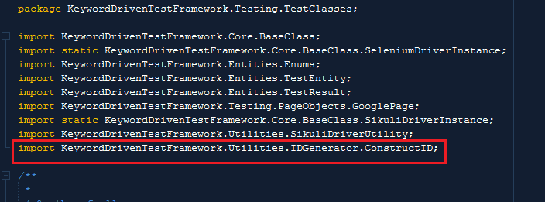
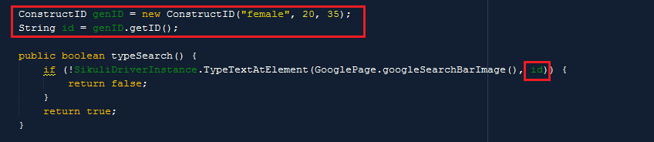
1. Import the ConstuctID class.
2. Inistialize ConstuctID class and pass in: “Male”/”Female”, minimum age, maximum age. Use the getID() method to store the generated RSA ID number to a variable that you can use to complete fields with.

